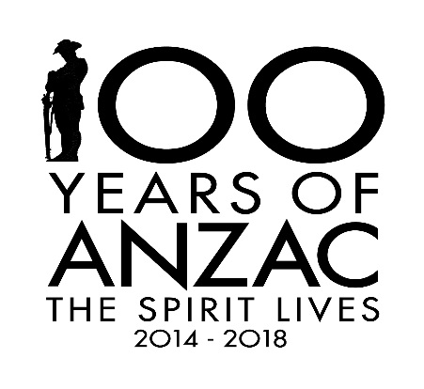
LAUNCH OF THE ANZAC COMMEMORATION BOOK
On 12 November 2016, the Fleurieu Peninsula Family History Group book, World War 1 ANZACS of the fleurieu peninsula: Stories from Pioneer Families will be launched between 2.00 and 4.00pm at the Arts Centre, Port Noarlunga. All members who have contributed to the book will automatically receive an invitation. As space is limited we are issuing tickets. We hope that members will want to attend but we need to know who is coming. If you would like to attend please contact me (Kath Fisher) on kathfisher6@hotmail.com or on 0419036419 and I will issue you with a ticket. Please do before the end of September.
All family members who contributed to book will receive two invitations per family.
For non-members who wish to attend please contact me. It is expected that not everyone will be able to attend and therefore the first who make contact will not have a problem with getting a ticket.
The programme of Commemoration will include members of the Noarlunga 40 Army Cadets; soldiers from Re-enact SA; family members of soldiers and nurses in the book; displays; entertainment and light refreshments.
This event is funded by a Commonwealth Grant (Anzac Centenary Local Grants Program) and fund raising by members of the project committee and the Aussie Group.

